Image Recognition System
🚀 Project Roadmap: Advanced AI Computer Vision Platform
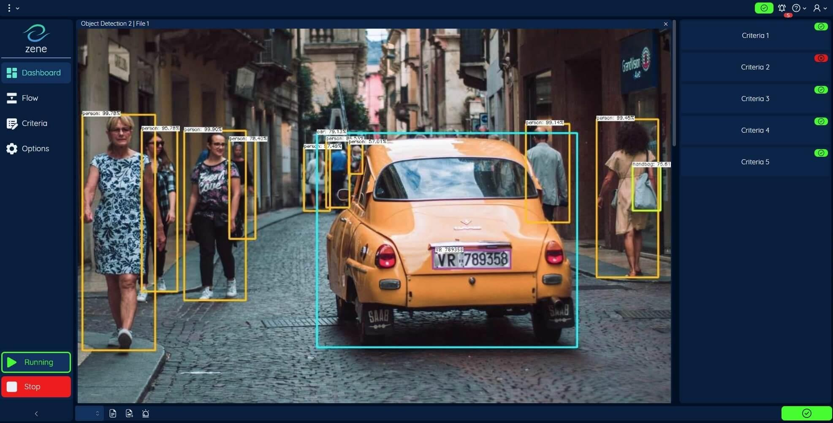
AI Vision Studio
Proposed project name — hum ise baad mein change kar sakte hain.
Ek web application jahan user images aur videos upload kar sakega, AI predictions dekh sakega, real-time object detection kar sakega aur analytics, visual search aur explainable AI use kar sakega.
1. Sabse pehle final features decide karte hain
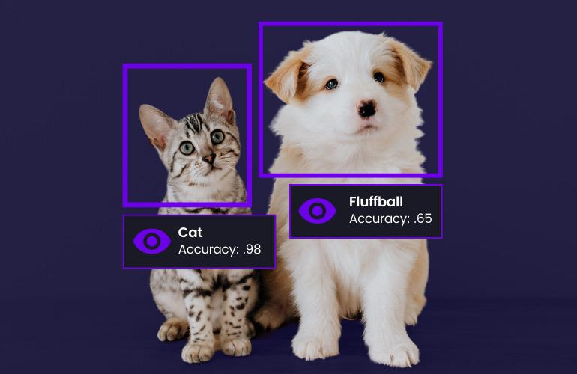
1. Smart Image Recognition
- Single aur multiple image upload
- Top 5 predictions aur confidence scores
- Batch image processing
- Prediction results save karna
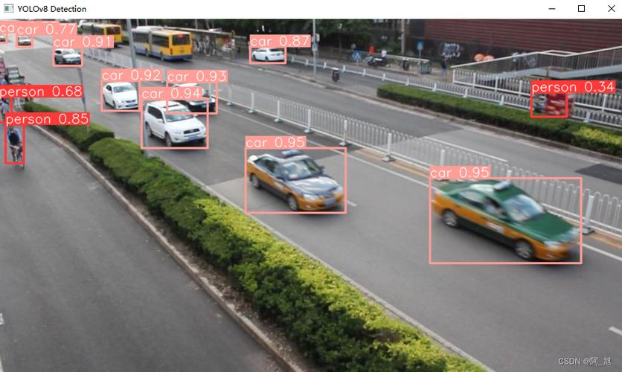
2. Real-Time Object Detection
- Webcam aur video detection
- Bounding boxes, object names aur confidence
- FPS aur processing time
- Video analysis aur annotated output
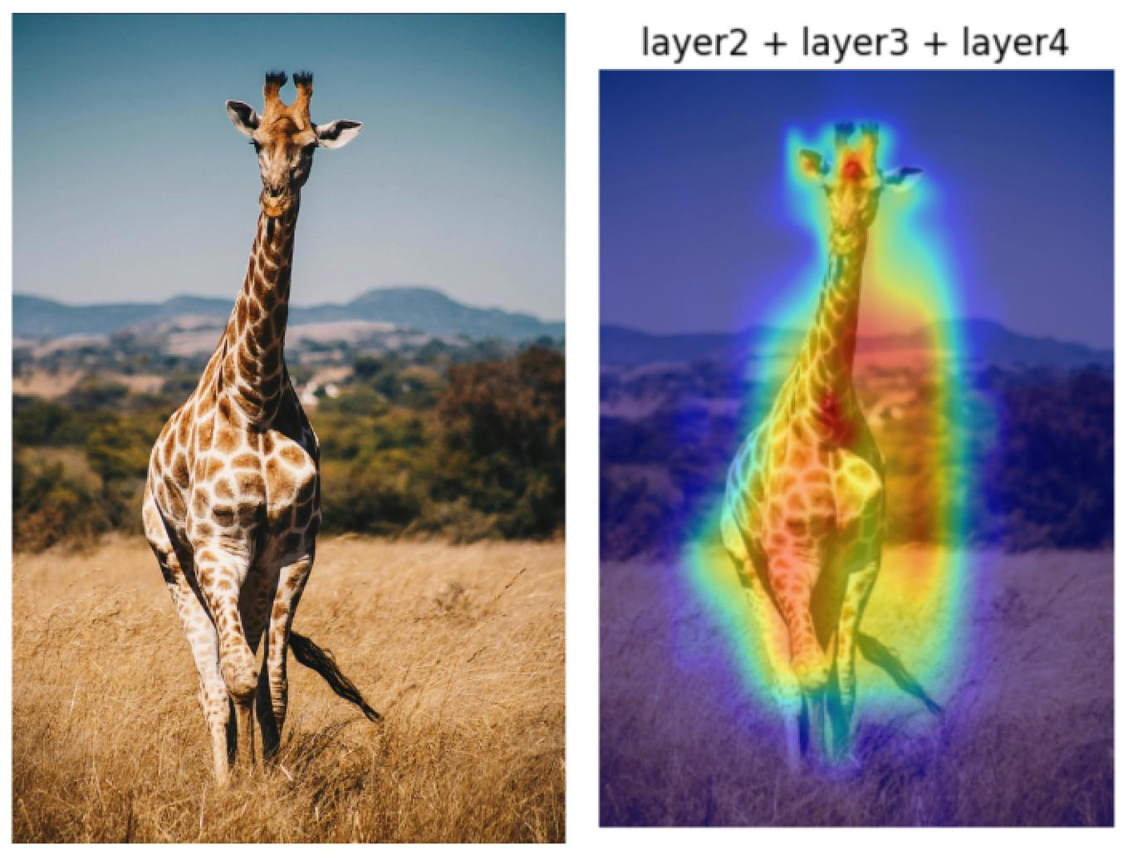
3. Explainable AI (XAI)
- Grad-CAM heatmaps
- Original vs analyzed image
- Model ke important image regions visualize karna
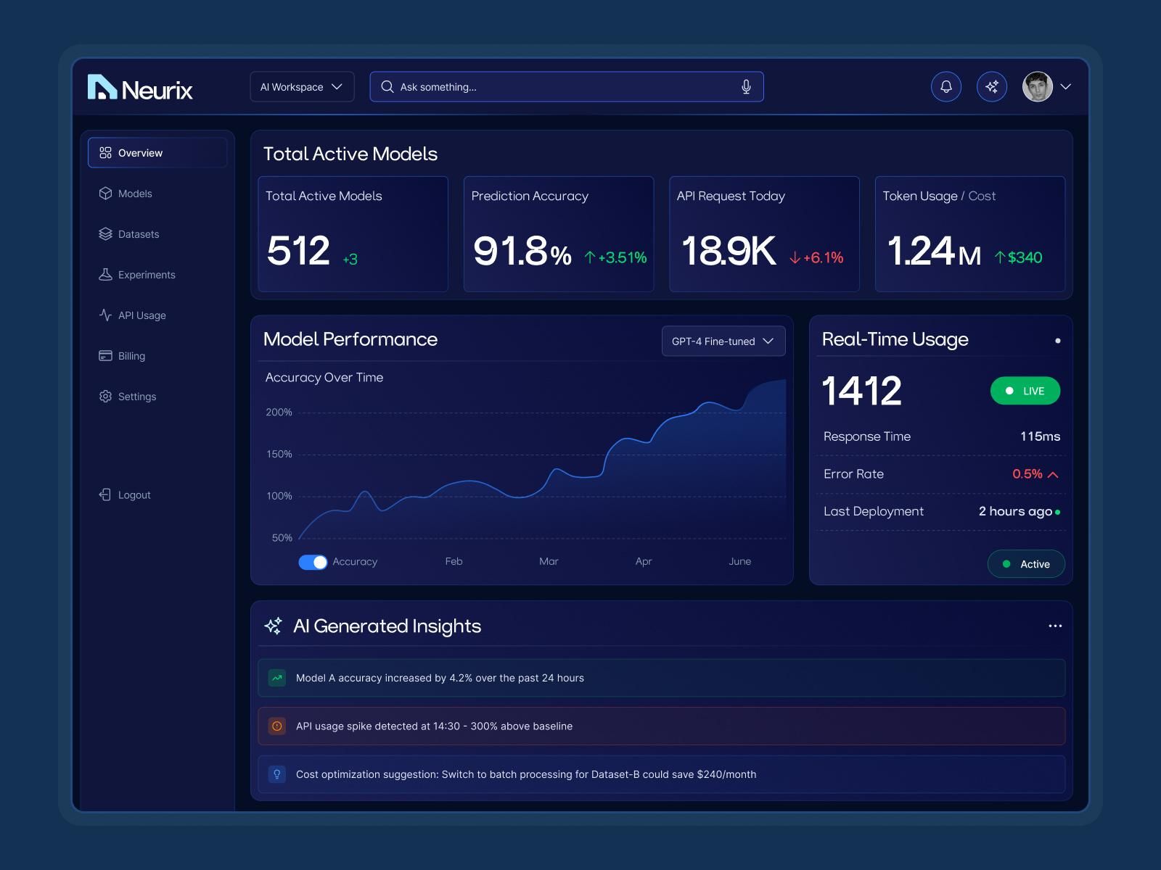
4. AI Analytics Dashboard
- Total predictions aur processed images
- Frequently detected objects
- Daily, weekly aur monthly charts
- Model accuracy aur latency reports
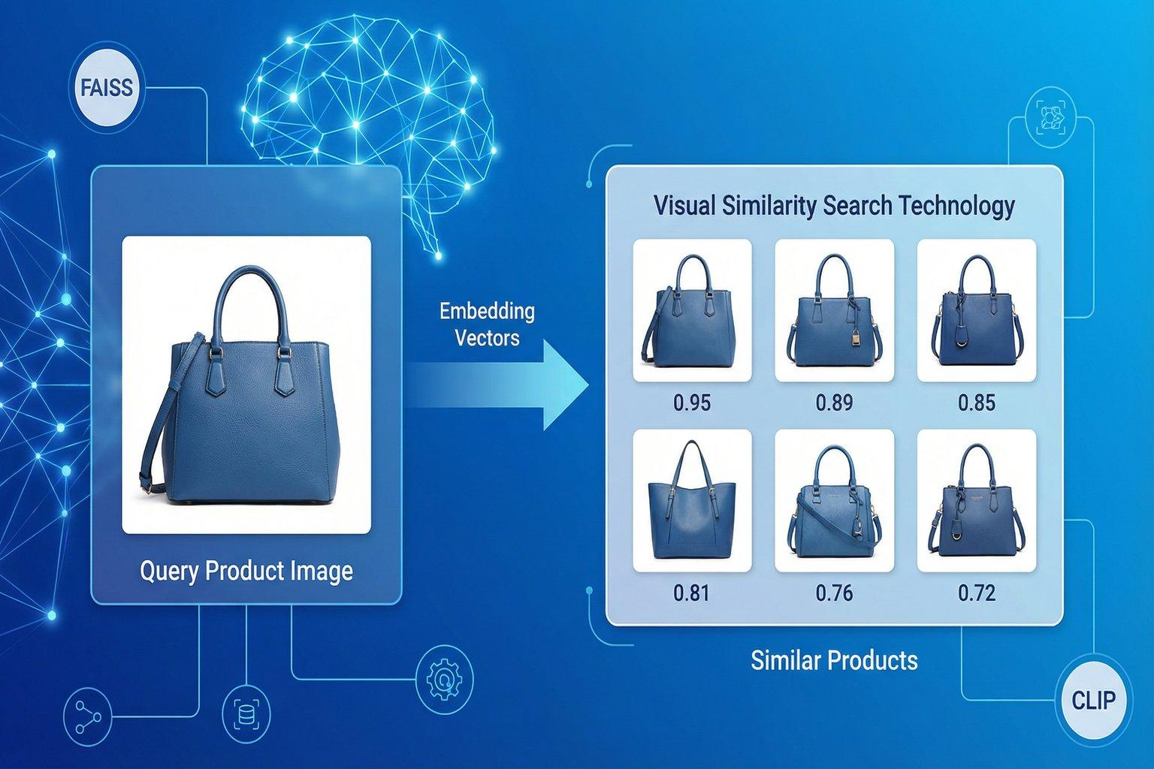
5. AI Visual Search
- Similar images search
- Duplicate aur near-duplicate detection
- Image embeddings, CLIP aur FAISS
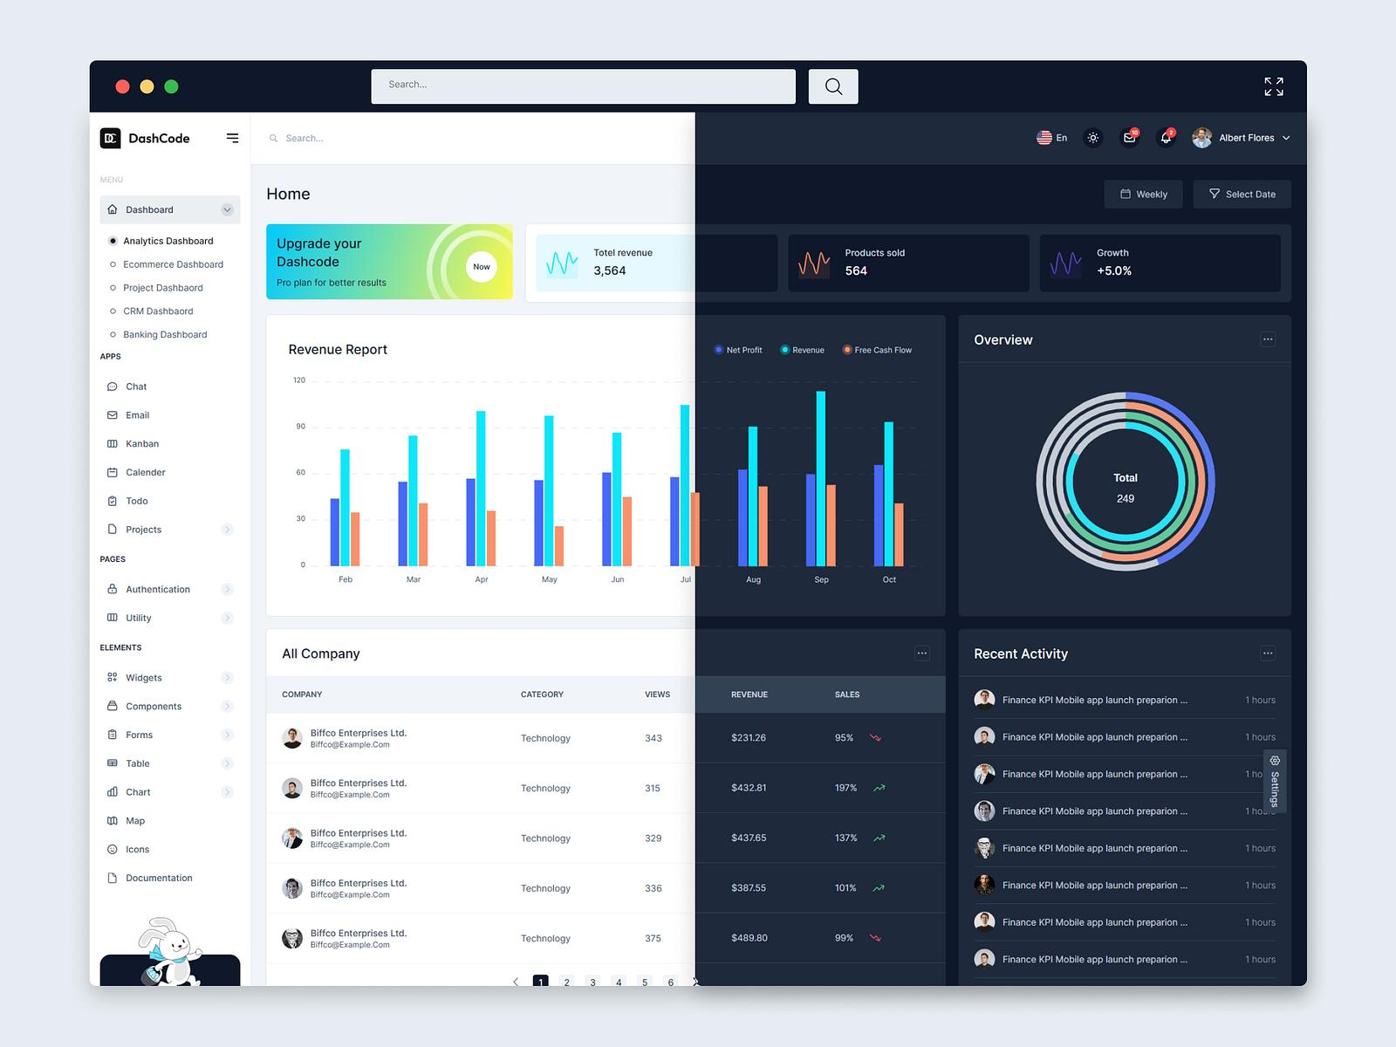
6. Complete Web Application
- Login, registration aur user profile
- Prediction history
- Report export
- Responsive UI, dark/light mode
- Admin aur user dashboard
2. Additional advanced AI modules
Inhe core system ke baad integrate karenge.
Module | Kaam
Image Segmentation | Object ke exact pixels identify karna
OCR | Images aur documents se text extract karna
Zero-shot Classification | Custom text labels par classification
Image Captioning | Image ka automatic description
Anomaly Detection | Unusual ya defective items flag karna
Active Learning | Reviewed predictions se future training improve karna
Model Comparison | Different models ki speed aur performance compare karna
REST API | External applications ko AI services dena
Important: Har feature ke liye suitable model, dataset aur testing chahiye. Kuch features pretrained models se ban sakte hain; anomaly detection aur domain-specific accuracy ke liye additional training ki zaroorat pad sakti hai.
3. Complete step-by-step development plan
Hum neeche diye gaye sequence mein project banayenge. Har step ka code aur verification complete hone ke baad hi aage badhenge.
Phase 1 — Planning aur Setup
Steps 1–5
- Step 1: Requirements, features aur final architecture
- Step 2: Python, Node.js, Git aur VS Code install/check
- Step 3: Project directory aur virtual environment create karna
- Step 4: Git repository aur .gitignore setup
- Step 5: Frontend aur backend ka initial project run karna
Phase 2 — Frontend UI
Steps 6–10
- Step 6: React + Vite + Tailwind CSS setup
- Step 7: App layout, sidebar, navbar aur routing
- Step 8: Dashboard, cards aur charts
- Step 9: Upload pages, result pages aur history screens
- Step 10: Responsive design aur dark/light theme
Phase 3 — Backend aur Database
Steps 11–15
- Step 11: FastAPI backend setup aur API structure
- Step 12: PostgreSQL database configuration
- Step 13: User registration, login aur authentication
- Step 14: Image upload, validation aur secure storage
- Step 15: Prediction history aur database models
Phase 4 — Core AI Recognition
Steps 16–20
- Step 16: Pretrained classification model integrate karna
- Step 17: Top 5 predictions aur confidence scores
- Step 18: Multi-image batch prediction
- Step 19: YOLO object detection aur bounding boxes
- Step 20: Video aur webcam detection, FPS aur latency
Phase 5 — Advanced AI
Steps 21–25
- Step 21: Grad-CAM explainability
- Step 22: Image segmentation
- Step 23: OCR aur image captioning
- Step 24: CLIP embeddings, FAISS aur visual search
- Step 25: Anomaly detection aur zero-shot classification
Phase 6 — Analytics aur APIs
Steps 26–29
- Step 26: Prediction analytics aur object frequency
- Step 27: Daily, weekly aur monthly reports
- Step 28: CSV/JSON export aur downloadable reports
- Step 29: REST API documentation aur API security
Phase 7 — Quality aur Security
Steps 30–33
- Step 30: Unit tests aur API integration tests
- Step 31: Invalid uploads, large files aur error handling
- Step 32: Permissions, rate limits aur secret management
- Step 33: Performance optimization aur model benchmarking
Phase 8 — Deployment
Steps 34–38
- Step 34: Production environment variables
- Step 35: Docker aur Docker Compose
- Step 36: Production database aur image storage
- Step 37: Frontend aur backend hosting, domain aur HTTPS
- Step 38: Final production testing, logs, backup aur documentation
Ye 38 milestones hain; actual coding tasks inke andar chhote-chhote steps mein honge. Agar koi feature kisi hosting platform par supported nahi hua, toh uska alternative choose karenge.
4. VS Code mein final folder structure
Hum structure ko shuru se organized rakhenge. Har folder aur file banane ka exact command aur code main us step par dunga.
text
ai-vision-studio/
│
├── frontend/
│ ├── public/
│ ├── src/
│ │ ├── assets/
│ │ ├── components/
│ │ ├── layouts/
│ │ ├── pages/
│ │ ├── features/
│ │ │ ├── recognition/
│ │ │ ├── detection/
│ │ │ ├── explainability/
│ │ │ ├── visual-search/
│ │ │ └── analytics/
│ │ ├── services/
│ │ ├── hooks/
│ │ ├── utils/
│ │ ├── App.jsx
│ │ └── main.jsx
│ ├── package.json
│ └── .env.example
│
├── backend/
│ ├── app/
│ │ ├── api/
│ │ ├── core/
│ │ ├── db/
│ │ ├── models/
│ │ ├── schemas/
│ │ ├── services/
│ │ ├── ml/
│ │ └── main.py
│ ├── tests/
│ ├── requirements.txt
│ └── .env.example
│
├── storage/
├── scripts/
├── docs/
├── docker-compose.yml
├── Dockerfile
├── .gitignore
└── README.md
storage/ ko production mein suitable persistent ya object storage se replace/configure karenge. Actual uploaded images, model weights, database passwords aur secret keys GitHub par upload nahi karenge.
5. Kaunsi technology use karenge?
Part | Technology
Frontend | React, Vite, Tailwind CSS
Backend | Python, FastAPI
Image classification | PyTorch ya TensorFlow/Keras — model ke hisaab se
Object detection | YOLO family + OpenCV
Explainable AI | Grad-CAM
Visual search | CLIP embeddings + FAISS
Database | PostgreSQL
Background jobs/cache | Redis, zaroorat ke hisaab se
Charts | Recharts ya Chart.js
Testing | Pytest + frontend testing tools
Packaging | Docker + Docker Compose
Deployment | Frontend hosting + backend hosting + managed database
Ek important baat: har model ko ek hi framework mein force nahi karenge. Jis model ke liye PyTorch best rahega, use PyTorch mein aur jis ke liye TensorFlow/Keras suitable hoga, use uske compatible environment mein rakhenge.
6. Har step mein main tumhe kya dunga?
Har milestone par ye process follow hoga:
- Kya banana hai: Feature ka simple explanation.
- Kahan banana hai: VS Code mein exact folder aur file path.
- Kaise banana hai: Terminal commands aur folder/file creation.
- Complete code: Copy-paste karne layak code, required imports aur configuration ke saath.
- Run kaise karna hai: Exact commands aur required terminal.
- Test kaise karna hai: Expected output aur functionality verify karna.
- Error aaye toh: Error ke according debugging aur fix.
- Next step: Current milestone verify hone ke baad hi aage badhna.
7. Deployment tak kin cheezon ka dhyan rakhenge?
- Free ya low-cost hosting options pehle evaluate karenge.
- Model size aur hosting ki RAM/CPU/GPU limits check karenge.
- Uploaded files ki size/type validation rakhenge.
- Login aur user-specific data secure rakhenge.
- Database migrations, environment variables aur production logs setup karenge.
- HTTPS, domain configuration aur deployment ke baad smoke tests karenge.
- Agar GPU hosting available nahi hui, toh CPU-compatible inference ya external inference service ka option rakhenge.
Note: Saare advanced modules ek working platform mein integrate karna possible hai, lekin development time, hosting cost aur model accuracy dataset aur hardware par depend karenge. Hum pehle ek functional core application banayenge, phir advanced features add karenge.
8. Ab hamara pehla step kya hoga?
Step 1: System aur development environment check. Code likhne se pehle tumhare computer par available tools aur hardware pata karna useful rahega, taaki unnecessary installations ya incompatible models choose na karein.

